Communication for Health Care Professionals 1
NCSI1182A
Module 3 Barriers to Effective Communication
Krystal Pitre/ Betty Lydon June 2023
Think About It!

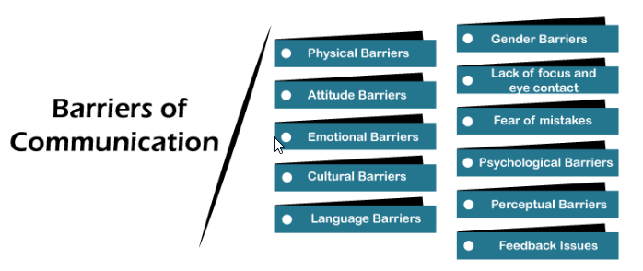

References:

In this module:

Goal: To discuss the barriers to effective communication.
Competencies:
- Discuss barriers that hinder effective communication
  - false reassurance
  - stereotyping, bias
  - judgement
  - advice or opinions
  - arguing
  - anxiety
Readings: Arnold and Boggs’s Interpersonal Relationships; Professional Skills For Canadian Nurses.

Introduction

“Effective clinical practice involves many instances where critical information must be accurately communicated. ... When health care professionals are not communicating effectively, patient safety is at risk for several reasons: lack of critical information, misinterpretation of information, unclear orders over the telephone, and overlooked changes in status.¹ One study found that 93 percent of communication is affected more by our body language, attitude, and tone, than by the meaning and intent based on the actual words said ³ Whereas the spoken words contain the crucial content, their meaning can be influenced by the style of delivery, which includes the way speakers stand, speak, and look at a person.^{¹”} (Wyoming department of Health, 2023, pg. 1)
Examples, of where barriers occur in nursing, are as follows:
Barriers to effective communication can occur within people when they are in these circumstances:
- Preoccupied with pain, physical discomfort, worry, or contradictory personal beliefs
- Unable to understand the nurse’s use of language, terminology, or frame of reference
- Struggling with a personal, emotionally laden, topic
- Feeling defensive, insecure, or judged
- Confused by the complexity of the message—too many issues, unrelated comments
- Deprived of privacy, especially if the topic is a sensitive one
- Have sensory or cognitive deficits that limit or compromise their ability to receive accurate messages
Barriers to effective communication within the nurse occur when the nurse is not fully engaged with the person for one or more of the following reasons:
- Preoccupation with personal concerns
- Being in a hurry to complete physical care
- Making assumptions about the person’s motivations
- Cultural stereotypes
- Defensiveness or personal insecurity about being able to help the person
- Thinking ahead to the next question
- Intense emotion or aggressiveness by the person
- Comments that do not add value to the conversation

Barriers That Hinder Effective Communication
Although there are many factors that contribute to poor communication, we will concentrate on the following six:
  - false reassurance
  - stereotyping, bias
  - judgement
  - advice or opinions
  - arguing
  - anxiety

False Reassurance
How would you feel if someone told you that you were going to be ok but you were not? Told you that your lab values were not “that bad” when actually they were. Giving false hope or information can be detrimental to your patient or their families.
“False Reassurance– “Don’t worry, everything will be all right.” When a client is seriously ill or distressed, the nurse may be tempted to offer hope to the client with statements such as “you’ll be fine.” Or “there’s nothing to worry about.” When a patient is reaching for understanding these phrases that are not based on fact or based on reality can do more harm than good. The nurse may be trying to be kind and think he/she is helping, but these comments tend to block conversation and discourage further expressions of feelings. A better response would be “It must be difficult not to know what the surgeon will find. What can I do to help?” (MECC.edu. Pg.4)


Reference:

“Truthfulness and honesty is a basic building block in establishing trust. Studies show that people and their families or substitute decision makers want “complete honesty,” and most prefer complete disclosure” (Arnold and Boggs, Pg. 230).
Barriers to truthfulness and honesty
“Sometimes it is not as easy to maintain truthfulness as we would hope. For example, the physician may not have yet told the person what you already know, which is that the person has been diagnosed with Stage 3 cancer. Any deception (lies or omissions) erodes trust in care providers. There may be a need to balance truth-telling with following nursing practice standards, where communicating a diagnosis is not in the nurse’s scope of practice. In situations like this, you can explore with the person what they are worried about and make every effort to have the physician speak with the person as soon as possible” (Arnold and Boggs, pg. 232).
Stereotyping/Bias
“Everyone has conscious and unconscious biases. We need to make it a goal to be self-aware of our biases and recognize a person as a unique individual, both different from and similar to self. Acceptance of the other person needs to be total. Unconditional acceptance, as described by Rogers (1961), is essential in the therapeutic relationship. It does not imply agreement or approval; acceptance occurs without judgement “(Arnold and Boggs, pg. 232).
In order to be self-aware, you must first understand the difference between a bias and a stereotype. Although they are similar, they are not the same. “The difference between bias and stereotype is that a bias is a personal preference, like or dislike, especially when the tendency interferes with the ability to be impartial, unprejudiced, or objective. On the other hand, a stereotype is a preconceived idea that attributes certain characteristics (in general) to all the members of class or set (Diffin .com, 2023).
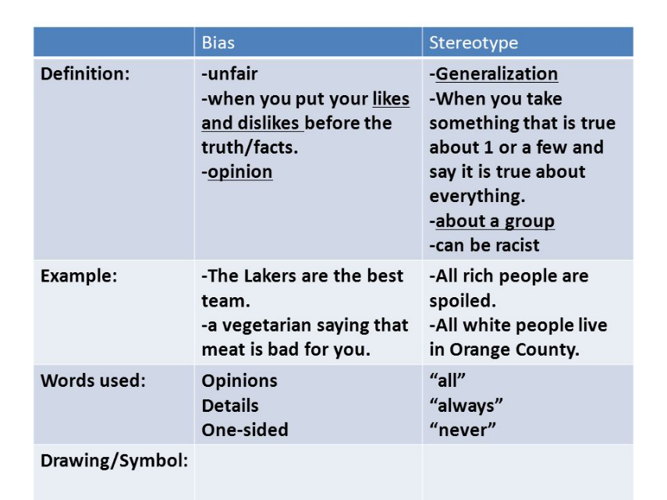
“Stereotyping acts as a communication barrier. This is the process of attributing characteristics to a group of people as though all people in the identified group possess them. People may be stereotyped according to ethnicity culture, religion, social class, occupation, age, sexual orientation, and other factors. Even health issues can be the stimulus for stereotyping individuals. For example, alcohol addiction, mental health disorders, and sexually transmitted infections often have stereotypes, stigma, and biases attached to them. Stereotyping people in a group rather than looking at each person as an individual with unique characteristics leads to negative consequences in unconsciously influencing our judgement and responses to those we are stereotyping. Stereotypes develop through cultural contexts, communications, experiences with parents and peers, and behaviours portrayed in the media “(Arnold and Boggs, pg. 232).
“Stereotypes are never completely accurate. No attribute applies to every member of a group. All of us like to think that our way is the correct way, and that everyone else thinks about life experiences just as we do. The reality is that there are many perspectives and no one way of thinking is necessarily better than another. Emotions play a role in the value we place on negative stereotypes. Stereotypes based on strong emotions are called prejudices and racism, and these ways of thinking can result in discrimination “(Arnold and Boggs, pg. 232).
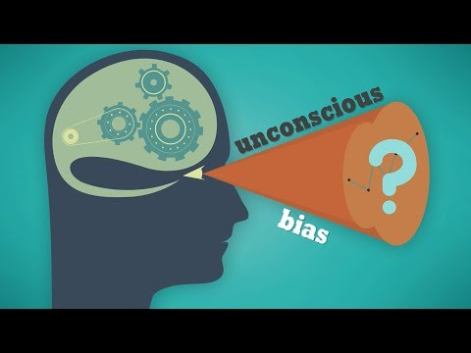
Reference

Judgment
“A judgment is a statement that takes facts of a situation and adds a personal preference, value, or opinion to it in an objective manner.
For example, “The rain is terrible” is a judgment because it is your opinion, and others may feel differently about the situation. “It is raining today. I notice I feel sad when it rains” is a non-judgmental statement that clearly portrays what’s actually happening in the situation (Sakrani, 2023. Pg.1)
“Nurses should strive to be nonjudgmental when caring for patients. Nonjudgmental, holistic care helps promote well-being and may improve the patient’s mental, physical, emotional and spiritual health. …Harmful societal attitudes — discrimination and judgement — can hinder the healing process and are unprofessional and unethical. As a nurse, you can help your patients by providing kind, nonjudgmental care that acknowledges all aspects of your patients’ makeup. … Nonjudgmental, holistic care affirms the dignity of your patients and helps them have a voice in their healthcare” (astate.edu. pg. 1).
Judging is one of the barriers that prevent information flow in communication. As an example, if one person is suspecting that you judge him/her, he/she will not open up to you and tell you all that they want to tell you. Instead, they will tell you what they think is 'safe' to tell you. Make sure that you do not judge people when you communicate with them. Judging makes others feel that one person is on a higher level than the rest (MCCC Ed.)
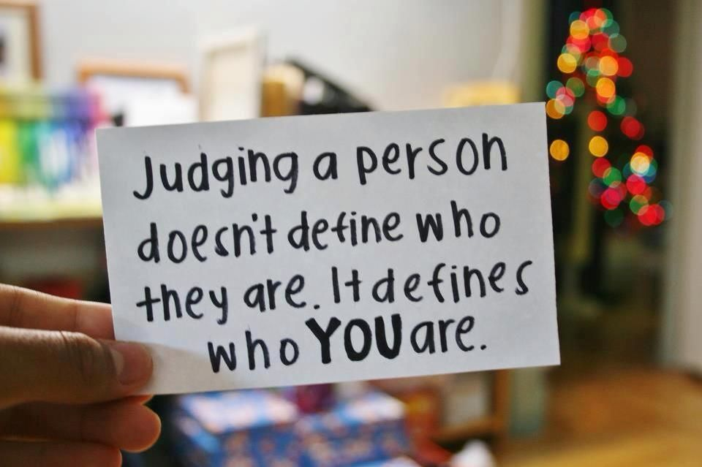
Reference:
Please review the following article to help you be more non judgmental:
READING: NON-JUDGEMENT FOR BEGINNERS

Advice or Opinions
Offering advice to a client is a barrier to therapeutic communication and should be avoided. Advice and opinions tends to interfere with the client's ability to make personal decisions, blocking the communication of their feelings, ideas, and personal choices.
Giving Personal Opinions | Giving personal opinions takes away the decision-making from the patient. Effective problem-solving must be accomplished by the patient and not the nurse. For example, stating, “If I were you, I’d put your father in a nursing home” is not therapeutic. Instead, it is more therapeutic to say, “Let’s talk about what options are available to your father.”
Reflecting | Patients often ask nurses for advice about what they should do about particular problems. Nurses can ask patients what they think they should do, which encourages them to be accountable for their own actions and helps them come up with solutions themselves.
(Potter, 2009. Pg.355)
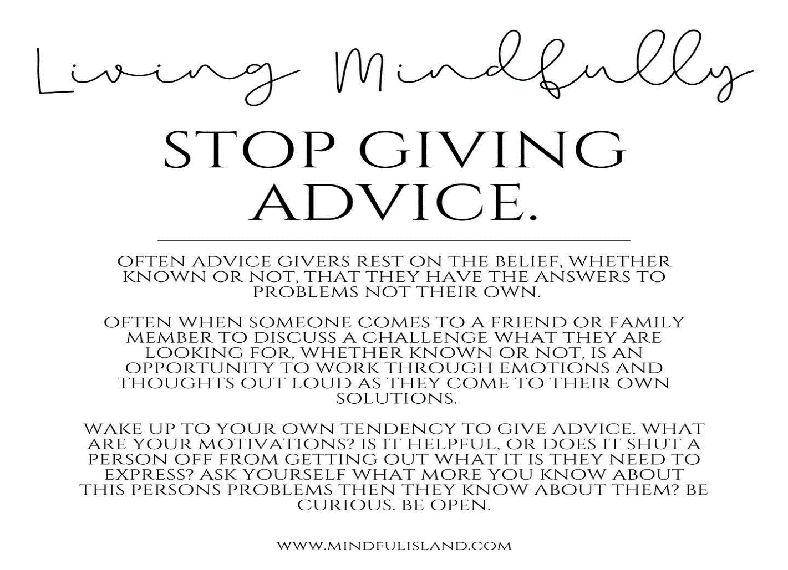
Arguing
“Conflict is a natural part of human relationships. We all have times when we experience negative feelings about a situation or person, but in nursing, it can compromise the person’s safety. When conflict occurs, direct communication is needed… Effective nurse–person communication is critical… When conflict occurs, knowing how to respond calmly allows you to use feelings as a positive force. Some people approach their initial encounter with a nurse with verbal hostility or even physical aggression, …Maintaining safety for self and others in your care is paramount. To listen and respond creatively to intense emotion when your first impulse is to withdraw or retaliate demands a high level of skill, empathy, and self-control…. professionals must always demonstrate respect for the people they care for… In the nurse–person relationship, the nurse is responsible for maintaining the professional conduct of the relationship. “(Arnold and Boggs, pg. 266a).
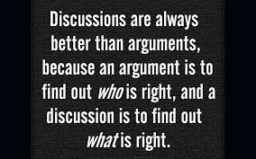
Arguing with your client or co workers is a normal part of conflict, however, arguing with your patient shows a sense of assumption and judgement. When you argue with your patient or their families it destroys any relationship or rapport you may have with them. Challenging or arguing patient perceptions denies that they are real and valid to the other person. They imply that the other person is lying, misinformed, or uneducated (MCCC Ed.)
Arguing with clients and coworkers also exhibits unprofessional/ unethical behavior. “ Controversy and open conflict are not tolerated “(Arnold and Boggs, pg. 165).

Anxiety
Anxiety is a part of everyday life and is normal. It is the bodies response to stressful situations Anxiety is not always a bad thing. It can help us stay alert, motivate us to solve problems and spur us on. However, too much anxiety can also interfere with life, coping and communication with others.
“It takes a lot of mental energy to hold a conversation, even if it doesn't seem like it. So it should come as little surprise that when your mind is overwhelmed with anxiety it can impair your ability to communicate” ( Abraham, 2020. Pg.1)
“Feeling anxious can become a personal barrier to communication in a person-centered relationship. Anxiety is a vague, persistent feeling of impending doom. It is a universal feeling; no one fully escapes it. The impact on the self is always uncomfortable. It occurs when one perceives a threat (real or imagined) to one’s self-concept. Lower satisfaction with communication is associated with increased anxiety. Anxiety is usually observed through the physical and behavioral manifestations of the attempt to relieve anxious feelings. Although individuals experiencing anxiety may not know they are anxious, specific behaviors provide clues that they are“(Arnold and Boggs, pg. 234).
“There is no single issue that impairs communication when you have anxiety. Rather, there is a host of potential issues that can make it difficult to communicate. Some examples include:
- Distracted Thinking One of the main issues caused by anxiety may be distracted thinking. You may find yourself anxiously thinking about numerous things, find yourself overly focused on the way you feel, or find yourself stuck on a particular thought. Regardless of what the issue is, distracted thinking makes it very hard to listen and hold a conversation, and your ability to communicate is impaired as a result.
- Overthinking From Nervousness Being nervous can create problems with overthinking. When you're nervous while talking to someone else, it's not uncommon to overthink each and every word you're about to say in an effort to make sure that you say the right thing. But when you are rethinking everything you are about to say, it disrupts the natural flow of conversation.
- Trouble Listening When you are focused on your anxiety it can cause trouble with listening and understanding what the other person is saying. This is often due to the distracted thinking, as mentioned above. Becoming anxiously focused on the person’s facial expressions or nonverbal communication can impact your ability to listen and pay attention to what they are saying. Anxiety about the content of the person's message may lead you to focus too much on any one particular word or phrase which can cause you to miss out on the other content that is necessary to respond correctly.
While all types of anxiety can impair communication, different issues may come up based on the type of anxiety you experience” ( Abraham, 2020. Pg.1)
Types of Anxiety
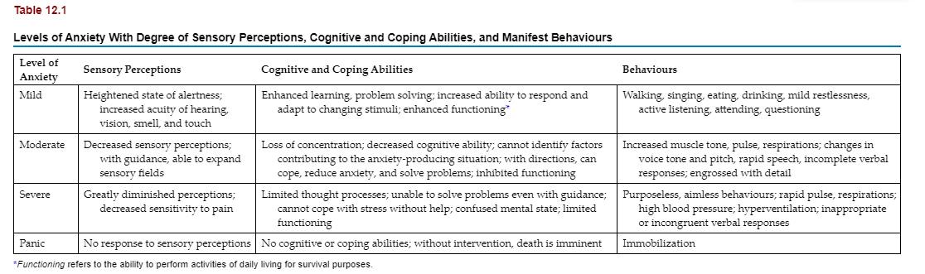
Nursing Strategies to Reduce Anxiety
For the Person
- Use active listening to show acceptance.
- Be honest; answer all questions at the person’s level of understanding.
- Explain procedures, surgery, and policies, and give appropriate reassurance based on data.
- Act in a calm, unhurried manner.
- Speak clearly, slowly, and firmly (but not loudly).
- Give information regarding laboratory tests, medications, treatments, and rationale for restrictions on activity.
- Set reasonable limits and provide structure.
- Encourage self-affirmation through positive statements such as “I will” and “I can.”
- Use drawings or play therapy with dolls, puppets, and games with youth.
- Use touch where appropriate.
- Initiate recreational activities, such as physical exercise, music, card games, board games, crafts, and reading.
- Teach deep breathing and relaxation exercises.
- Use guided imagery.
For Nurses
- Ensure adequate amounts of sleep.
- Eat a healthy diet.
- Exercise.
- Practise mindfulness activities, such as meditating, daily (even if only for 5 minutes).
- Use guided imagery, positive attitude, and positive affirmations.
- Listen to music.
- Practise yoga.
- Do journalling.
- Do deep breathing exercises. Download the Breathe app, and have it remind you to do deep breathing periodically.
- Take your assigned breaks to do some of the above!
Modified from Gerrard, B., Boniface, W., &amp; Love, B. (1980). Interpersonal skills for health professionals. Reston Publishing; TeamSTEPPS National Conference, June 2017.
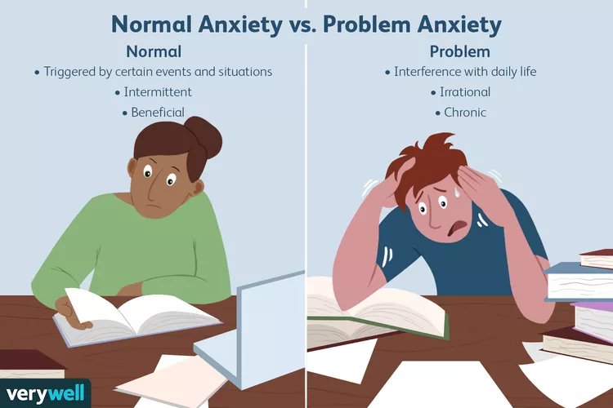
Reference:
References

Abraham, M. (2020). How Anxiety can Impair Communication. Retrieved from https://www.calmclinic.com/anxiety/impairs-communication#:~:text=Regardless%20of%20what%20the%20issue,can%20create%20problems%20with%20overthinking
Arkansas State University. 2017. Hoe to Provide Nonjudgmental Holistic Care . Retrieved fromhttps://degree.astate.edu/articles/nursing/provide-nonjudgmental-holistic-care.aspx

Boggs, C.M.O.Y.E.A. K. (2022). Arnold and Boggs's Interpersonal Relationships. Elsevier Health Sciences. Chapter 6 (US). https://pageburstls.elsevier.com/books/9780323763684
Diffen. Com (2023). Bias vs stereotype. Retrieved from https://www.diffen.com/difference/Bias_vs_Stereotype
Mercier County Community College (MCCC.edu). 2023. Therapeutic Communication. Retrieved from https://www.mccc.edu/nursing/documents/NRS225TherapeuticCommunications.pdf
Potter, P. (2017). Communicating with Patients Retrieved from https://wtcs.pressbooks.pub/nursingfundamentals/chapter/2-3-communicating-with-patients/
Sakrani, F. (2023). Nonjudgement for beginners. Retrieved from https://www.mindchicago.com/articles/non-judgment-for-beginners
Wyoming department of Health, 2023. Section 18: Patient Engagement. Retrieved from https://health.wyo.gov/publichealth/infectious-disease-epidemiology-unit/infection-prevention-orientation-manual/patient-engagement/#:~:text=Team%20collaboration%20is%20essential.,and%20overlooked%20changes%20in%20status

.

